Financial Assistance Application (Checklist) Veterans Assistance Commission of Macon County Check list information:

Completed and signed application
- Release of information (Included in Application)
- Fraud disclaimer form (Included in Application)
- Rights and responsibilities form (Included in Application)
- Copy of DD-214 ☐ ID and SSN card (ID and SS # for all dependents)
- Marriage Certificate ☐ Birth Certificates of ALL dependents in household
- Landlord Agreement ☐ W-9 Form ☐ Lease ☐ Property Printout (Rent & Mortgage)

All current household utility bills (Ameren)
- Bank Statements – last 90 days’
- Proof of ALL monthly household income – last 3 paystubs

  - Veteran $
- VA Disability – Award letter
- Spouse $

- Please include supporting documentation to verify emergency.

The following are the rights, privileges, and responsibilities of applicants for assistance through the Veterans Assistance Commission of Macon County.

Applicants have the following RIGHTS and PRIVILEGES:

You have a right to file a written application for assistance and to receive help in completing the application. Your responsibility is to provide all documentation showing income and emergency.
•

Your living arrangements must conform to the VAC rules. The VAC has the right to deny rent payments to parents and to third parties in sub-lease situations.
•

You have a right to expect the VAC to decide on your application for assistance within 30 days. You have a right to a decision in writing.
•

You have a right to appeal-in writing-any action, inaction, or decision of the VAC office to the President of the VAC Board or his/her designated representative. VAC staff will provide you with a "Notice of Appeal" and assist you in completing the form. The Chairman will convene a hearing to examine your case.
•

You are notified that Macon County Auditor only cuts check on Fridays normally 2 weeks following approval.

You have the right not to be discriminated against because of your race, religion, national origin, gender, age, physical impairment or political affiliation.
•

You have the right of privacy regarding the information you provide to the VAC. It must be kept confidential unless the VAC requires disclosure of the information to determine your eligibility for assistance or to coordinate your assistance with other agencies.
•

You have a right to be treated with respect and in a courteous and considerate manner.
•

You have a right to ask questions about your application and inspect, in the presence of VAC personnel, the case file containing your records and information during regular VAC office hours. However, the case file may contain certain information which has been provided to the VAC on the condition that it would not be revealed to you. The VAC has a right to remove such confidential information from your case file before you see it.
•

You are encouraged to contact other agencies and apply to other programs that may be of assistance. A list will be furnished to you at the time of your intake.
•

Applicants have the following RESPONSIBILITIES

You have the responsibility to treat the personnel working in the VAC office with courtesy and consideration. Any action or threat made by you to harm a VAC employee or behavior that is insulting and disrespectful may be grounds for denial of VAC assistance, expulsion from building, and/or arrest.
•

You must complete a written "Application for Assistance." The application will contain information used in evaluating your case.
•

A current photograph of all applicants is required in the VAC case file along with a State ID.
•

You must keep all scheduled appointments with VAC personnel. If a circumstance arises that prevents you from keeping your appointment, you must contact the VAC promptly.
•

You must provide the VAC with all the information and documentation needed for a determination of your eligibility and must assist the VAC in obtaining any other documentation that may be required.
•

If you are unable to work, you will need to provide a letter from your primary physician to confirm that due to what current condition causes you to be unable to work. They must also provide date you were unable to work and approximate date you will be able to start working again.
•

You must accept and follow through in good faith any referral by the VAC to any other agency or person or for any benefit that might alleviate your present needs. If you are referred to another human service agency for assistance and refuse to apply for help from that agency, the VAC may determine that you are ineligible for financial assistance on the basis that you failed to seek services and financial aid that might be available from a primary source.
•

You must notify the VAC of any change in your personal status such as job change, an altered family situation, a different dependent status, or any other material fact that would alter your eligibility.
•

You must consent to and sign "Fraud Disclaimer Form" and "Release of Information" statements so the VAC can obtain information and verify data given on your application. Providing false, fraudulent, or
•
misleading statements disqualifies applicants from receiving any assistance from the VAC and will result in criminal prosecution to the fullest extent of the law.

I understand that by Signining this release of information for Oasis Insight Software in order to share information with other charitable organizations.

By signing below you have received a copy of the Rights, Privileges, and Responsibilities of the VAC.

Veteran's Signature Date

Financial Assistance Application
Veterans Assistance Commission of Macon County
141 S Main Street Room 210
Decatur, IL 62523
(217) – 424-1376

Any person requesting Emergency Veterans Assistance from the Veterans Assistance Commission of Macon County must first fully complete an application and provide proof of military service, proof of income and meet the minimum requirements set by the Department of Veterans Affairs. Veterans who enlisted after September 7, 1980, must have served 24 continuous months or the full period, they were called to active duty in order to be eligible (this does not include active duty for training). The Veteran must have received an HONORABLE DISCHARGE or GENERAL UNDER HONORABLE, to be eligible. If the Veteran’s current or anticipated income exceeds +%50 of income poverty guidelines set forth by the U.S. Department of Health & Human Services, the Veteran will be ineligible for any assistance under this program. Veteran must provide proof of financial emergency. Veteran must pay %20 of overall bill from the last 90 days.
Veteran’s bill cannot exceed 90 days past due!
The following documents MUST accompany the application:
*Failure to prove all requested information will result in a delayed application process. Application must be complete.

Income Guidelines to qualify for assistance from The VAC of Macon County:

Income Rates | Annual | Monthly
Veteran/Applicant Alone | $19,320.00 | $1610.00
1 Dependent | $26,130.00 | $2155.00
2 Dependents | $32,580.00 | $2177.50
3 Dependents | $39,750.00 | $3312.50
4 Dependents | $46,560.00 | $3880.00
Updated: 01Jan2022

This program does not under any circumstances provide assistance for the following:
Gasoline, Clothing, Security Deposits, Insurance, Car Payments, Telephone Bills, First Month Rent, Home Finding Fees

Mortgage & Rental Payments:
Home must be in the Veterans name f and W-9 must be provided from the Mortgage company along with payment slip showing monthly mortgage payment. We do not pay utilities or rent to relatives, including immediate family members, nor do we pay rent to motels or hotels. We do not pay rent to secondary renters not established by the landlord. If qualified, rental assistance will only be paid to the landlord (owner of property) or the mortgage company. A copy of your lease must also accompany the rental application.

Utilities
We only pay Ameren Illinois for power and gas. Late Fees & Reconnection fees will not be paid.

The Veterans Assistance Commission is funded by the taxpayers of Macon County and is obligated to financially assist only Veterans of Macon County that have resided in Macon County 6 months.

Please indicate the month and year you became a Macon County Resident:

Veteran Information

Name:

Social Security #:
Date of Birth:

Address:

Phone #:
County:

Date you moved to this residence:

If you have lived at the above address for less than 6 months, please provide your previous address below:

Active-Duty Dates:

Characterization of Discharge:
**DD214 that proves honorable/general, under honorable service must accompany this application Veteran Employment Status:
Full-Time Δ Part-Time Δ Not Employed Δ Other

Place of Employment:

Previous Employment (If not currently employed, write previous employment and last day worked below):

Veteran Current Marital Status:

- Married Δ Single Δ Divorced Δ Separated Δ Widow/Widower Date of Marriage or Divorce:
County in which you were married:

Spouse/Widow Information
If Widow claiming under Veteran eligibility

Name:

Social Security #:
Date of Birth: _

Address:

Phone #:
County:

Employment Status:
Full-Time Δ Part-Time Δ Not Employed Δ Other

Place of Employment:

Previous Employment (If not currently employed, write previous employment and date last worked):

Children/Dependents
Are there any other adults living in the household? Δ Yes Δ No
If yes, please list below:
Name | Relationship | Social Security Number | Employment

Do you have any children or dependents? Δ Yes Δ No
If yes, please list below:
Name | Date of Birth | Resides in Home Full Time?

Financial Information
Include only monthly recurring monthly gross income and expenses. Do not include one-time assistance or accumulative balances on past due expenses. **Gross income must include of all persons in the household.

Monthly Gross Income (Receiving) Monthly Expenses (Paying Out)

Income of Veteran:
Rent/Mortgage:

Income of Spouse:
Electricity: _

VA Comp/Pension: _ Gas: _

Social Security: _ Water/Sewage: _ Child Support: _ Food: _ Other Income: _ Other:
Child Support PAID:

Total Income:
Total Expense: _

***If the Veteran, applicant or spouse is receiving: VA Pension, VA Compensation, Unemployment, any type of Social Security or Retirement/Pensions, the VAC will consider this as income. You must provide a statement at time of application submission.

The Veterans Assistance Commission program is an emergency assistance program and should NOT be considered an ongoing financial program. In order to assist you more, we need to know what other assistance programs you have applied for. Failure to completely document this in the following section will result in delay or denial of the application.
Our intentions are to assist you in applying for other services for which you may qualify.
***Other Income – You must list if you are currently receiving a reoccurring payment from any other source

Source | Date Applied | Status | Amount Approved
Private Charities |  | - Approved  - Denied  - Pending  - Not Eligible
SNAP (LINK) |  | - Approved  - Denied  - Pending  - Not Eligible
SSI |  | - Approved  - Denied  - Pending  - Not Eligible
SS Disability |  | - Approved  - Denied  - Pending  - Not Eligible
Post, Union or Squadron |  | - Approved  - Denied  - Pending  - Not Eligible
Unemployment |  | - Approved  - Denied  - Pending  - Not Eligible
TANF |  | - Approved  - Denied  - Pending  - Not Eligible

Other (Specify) |  | - Approved  - Denied  - Pending  - Not Eligible
Section 8 Eligible |  | - Approved  - Denied  - Pending  - Not Eligible
HUD Cash Voucher |  | - Approved  - Denied  - Pending

What is the type of assistance you are applying for today?

  - Rental Mortgage
  - Utilities

If you are applying for rental assistance, please list your landlord’s information W-9 must be provided along with Landlord Qualification Sheet:

Landlord Name:

Phone Number:

Below please describe the reason for applying for emergency assistance (this must be an emergency caused by no fault of your own) :

Applicant/Recipient cooperation in determining eligibility is required. Willful failure or refusal of the Applicant/Recipient to cooperate
with the VACMC shall result in the denial or termination of assistance, based on the VACMC's inability to determine eligibility.

Applicants must give true and complete information. lf an Applicant willfully misrepresents, lies or provides false information to qualify for or receive assistance, the VACMC may permanently deny the Applicant benefits. If an Applicant attempts to receive any benefits based on false or fraudulent information, the Applicant may be fined, charged with a crime, and /or reported to the internal Revenue Service (IRS).

Red-flagged: a determination by the VACMC that an applicant will be denied services for a minimum of twelve (12) consecutive months for a first offense. This determination may be made if:
- Applicant has made to the VACMC a misrepresentation to obtain assistance.
- Applicant has harassed, intimidated or been verbally/physically abusive with the VACMC staff.

Appeal Rights: If you disagree with the determination of this Office, you may file an appeal to the executive committee of the Macon County VAC. Your appeal must be filed in this office within thirty (30) days after the date of the aforesaid determination, in the case of mailing, the thirty (30) calendar days shall begin three (3) business days after the date of postmark. Appeal forms are available on request.

I, the applicant, certify that the information contained in this application is true and current to the best of my knowledge. By signing below I give the Veterans Assistance Commission of Macon County the authority to completely verify all information provided. Release of information

Printed Name

Signature Date

Spouse Signature Date

Fraud Disclaimer Form Memorandum of Understanding

NOTE: Before signing this form, please understand that the Veterans Assistance Commission of Macon County provides a valuable service to the veterans, widows, and specified dependents of this county. Abuse of any services provided by this office will not be tolerated.

I (we) fully understand that failure to report or disclose all necessary documentation pertaining to proof of veterans status, sources of income, expenses and other data requested by this County office, or as required by Illinois of Federal Law, or the requirements of this US Department of Veterans Affairs can delay a VA claim and may result in the denial of a VACMC Interim or Emergency Assistance. I (we) fully understand that it is unlawful to impersonate a veteran for personal gain.

Please Read the following State Statue Below:
720 ILCS 5/17-6) (from Ch. 38, par. 17-6)
Sec. 17-6. State benefits fraud.

- A person commits State benefits fraud when he or she obtains or attempts to obtain money or benefits from the State of Illinois, from any political subdivision thereof, or from any program funded or administered in whole or in part by the State of Illinois or any political subdivision thereof through the knowing use of false identification documents or through the knowing misrepresentation of his or her age, place of residence, number of dependents, marital or family status, employment status, financial status, or any other material fact upon which his eligibility for or degree of participation in any benefit program might be based.
- Notwithstanding any provision of State law to the contrary, every application or other document submitted to an agency or department of the State of Illinois or any political subdivision thereof to establish or determine eligibility for money or benefits from the State of Illinois or from any political subdivision thereof, or from any program funded or administered in whole or in part by the State of Illinois or any political subdivision thereof, shall be made available upon request to any law enforcement agency for use in the investigation or prosecution of State benefits fraud or for use in the investigation or prosecution of any other crime arising out of the same transaction or occurrence. Except as otherwise permitted by law, information disclosed pursuant to this subsection shall be used and disclosed only for the purposes provided herein. The provisions of this Section shall be operative only to the extent that they do not conflict with any federal law or regulation governing federal grants to this State.
- Any employee of the State of Illinois or any agency or political subdivision thereof

may seize as evidence any false or fraudulent document presented to him or her in connection with an application for or receipt of money or benefits from the State of Illinois, from any political subdivision thereof, or from any program funded or administered in whole or in part by the State of Illinois or any political subdivision thereof.
- Sentence.
  - State benefits fraud is a Class 4 felony except when more than $300 is obtained, in which case State benefits fraud is a Class 3 felony.
  - If a person knowingly misrepresents oneself as a veteran or as a dependent of a veteran with the intent of obtaining benefits or privileges provided by the State or its political subdivisions to veterans or their dependents, then State benefits fraud is a Class 3 felony when $300 or less is obtained and a Class 2 felony when more than $300 is obtained. For the purposes of this paragraph (2), benefits and privileges include, but are not limited to, those benefits and privileges available under the Veterans' Employment Act, the Viet Nam Veterans Compensation Act, the Prisoner of War Bonus Act, the War Bonus Extension Act, the Military Veterans Assistance Act, the Veterans' Employment Representative Act, the Veterans Preference Act, the Service Member's Employment Tenure Act, the Disabled Veterans Housing Act, the Under Age Veterans Benefits Act, the Survivors Compensation Act, the Children of Deceased Veterans Act, the Veterans Burial Places Act, the Higher Education Student Assistance Act, or any other loans, assistance in employment, monetary payments, or tax exemptions offered by the State or its political subdivisions for veterans or their dependents.
(Source: P.A. 96-1551, eff. 7-1-11.)

By signing this document you understand that falsifying any information on your application to receive financial assistance from the VAC can result in State Benefits Fraud.

Print Name- Veteran Date

Signature- Veteran

Print Name- Spouse Date

Signature- Spouse

Applicant’s Name:
Social Security Number:

Address:
Telephone Number:

I understand that it will be necessary for the Macon County Veterans’ Assistance Commission (VAC) representative to discuss and verify information about my financial situation, employment information, and certain eligibility information for assistance through the VAC.

I hereby acknowledge that the information related to my eligibility for the VAC benefits requires certain verification and documentation and by my signature below, I, authorize other agencies and/or individuals to release information regarding my personal financial income, debts presently owed by the family, and any other information deemed necessary by the VAC.

I understand and acknowledge that, if any of the information related to my application has been falsified, I may be terminated from the program and subject to legal prosecution to the fullest extent of the law by the Macon County State’s Attorney.

I certify to the best of my knowledge that all statements made to the VAC are true, and there is no intent to commit fraud. I understand that the information obtained by the VAC may be shared with other agencies for the purpose of verifying my eligibility for emergency assistance.

I also understand that I will be required to apply for and/or participate in any program deemed appropriate by the VAC. In that regard, if I am deemed able to maintain full-time employment, I will be required to provide proof of a concerted effort to obtain such employment. This instrument shall authorize those facilities that I list as locations at which I applied for employment to furnish the information needed to the Macon County VAC.

I hereby authorize the following persons or agencies to release information requested by the Macon County VAC to: Macon County Veterans’ Assistance Commission; 141 S Main St, Suite 210; Decatur, IL 62523; (217) 424-1376.

- Illinois Department of Human Services h. Intergovernmental Departments/Offices
- Illinois Department of Employment Security i. Probation & Court Services
- Illinois Department of Veterans Affairs j. Township General Assistance Departments/Offices
- Department of Veterans Affairs k. Agencies to which Vouchers are issued/processed
- Social Security Administration l. Agencies to which household has applied for asst
- Oasis Insight, Northeast Community Fund m. Other:
- Salvation Army, United Way Reason for Request::

A photo static or faxed copy of this document shall suffice as proper authorization for release of the above information.
This document shall suffice as authorization to release necessary information.

Applicant’s/Legal Representative’s Printed Name:

Applicant’ Signature: _ Date: _

Financial Assistance Application
(Only if applying for mortgage or Rental assistance )
Veterans Assistance Commission of Macon County
141 S Main Street Room 210
Decatur, IL 62523
(217) 424-1376
Fax (217) 718-4760

Landlord Sheet

To Whom It May Concern:

I, am the owner of the property located at , which is currently rented to
and they owe me $

Rent for the period of to .

Landlord’s Signature:

FEIN # or Social Security Number:

Address:

City, State & Zip:

Telephone #:

Please fill out attached W-9. These forms can be brought in, Faxed to 217- 718-4760 or emailed to the superintendent @ gcollins@maconveterans.us

*FALSE INFORMATION WILL RESULT IN DISQUALIFICATION and/or prosecution.

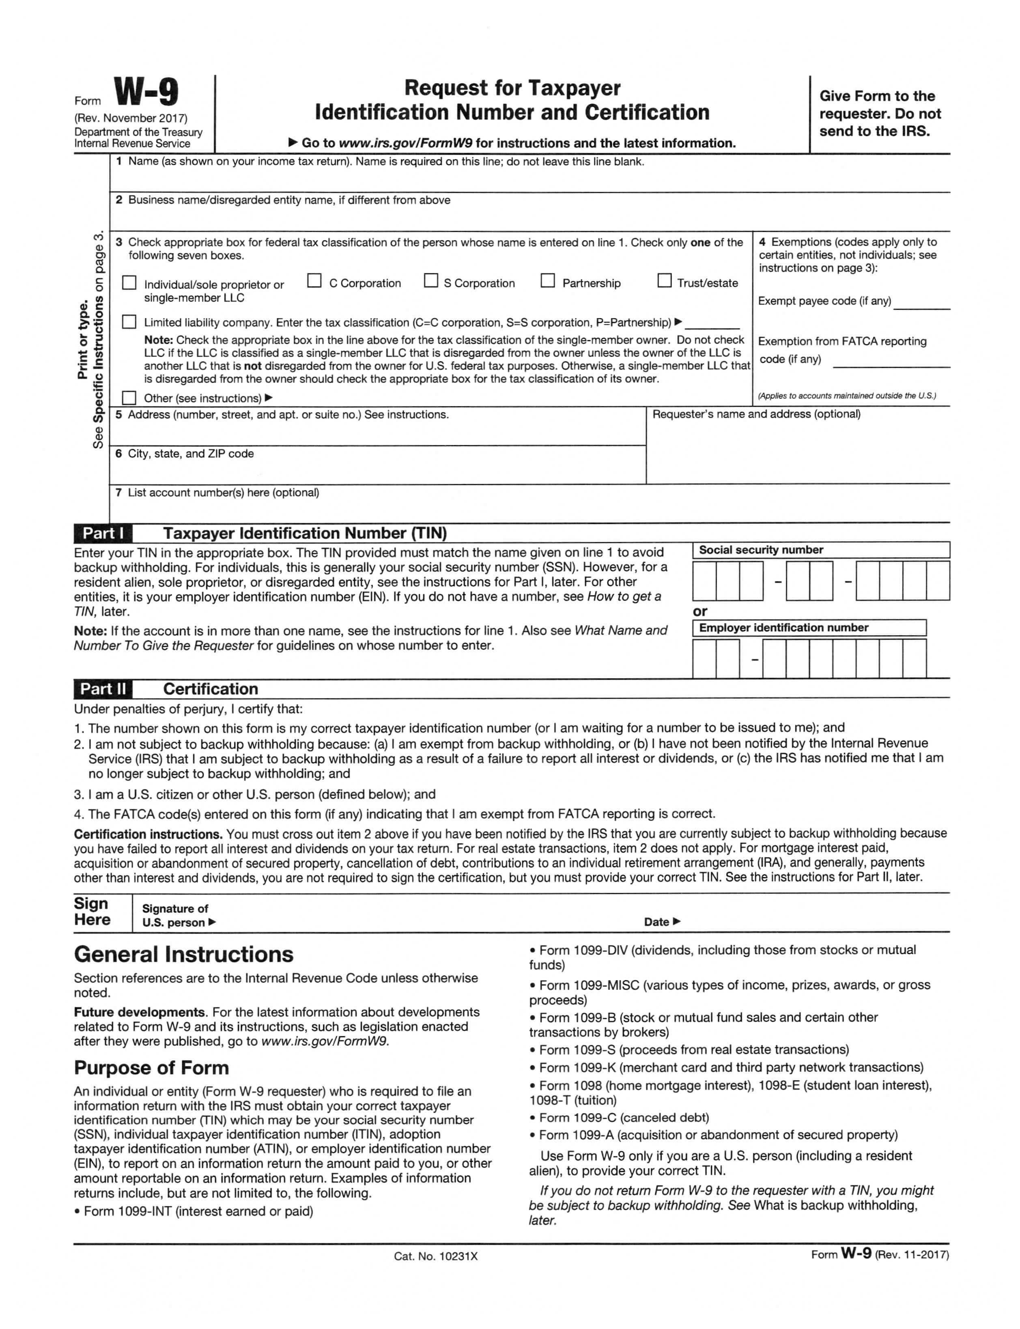VAC OF MACON COUNTY - RENTAL OR MORTGAGE ASSISTANCE ONLY

Page 14 of 14 Macon County VAC Application

